# Reference: Setup a MultiSim Live Premium Account

If you already have a MultiSim account, skip to Step 2.

1. Go to https://www.multisim.com/
   1. Click on the yellow “SIGN UP” button.
   2. Enter your personal information on the “Create an NI User Account”.
   3. Click “CREATE ACCOUNT”.
   4. Go back to the www.multisim.com and sign in.
2. Enable Premium
   1. Log into: <https://download.mines.edu/>.
   2. Login with your Mines credentials.
   3. Look for the NI LabView Student Install Serial Number. This number is the MultiSim serial number asked for in the next step.
   4. Back in your MultiSim browser page, navigate to your Profile Settings.

S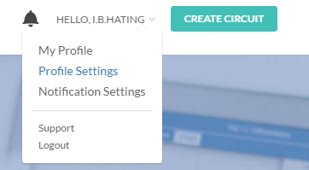

* 1. Enter your MultiSim serial number in the **New Serial Number** field.
  2. In a few moments, the serial number should be verified.

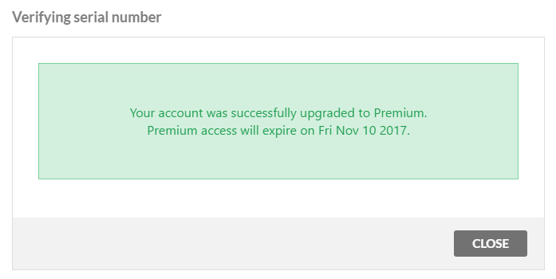

Congrats! You will not have to do this for the remainder of the term.